S Perry - IT Portfolio Projects (With Screenshots)

Linux User Provisioning & Group Management
Created users, assigned group memberships, configured passwords, and verified access.
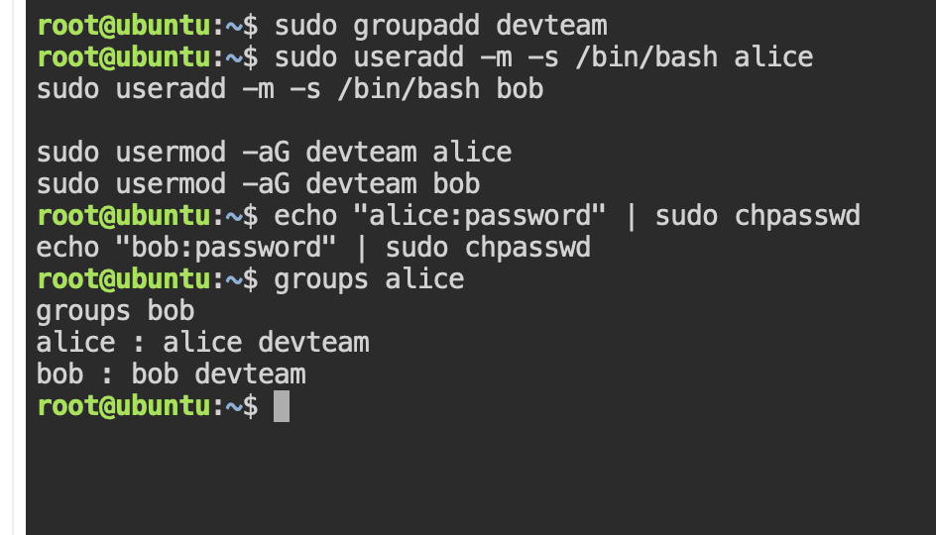

Linux File Permissions & Access Control
Configured file ownership and permissions, then verified access restrictions.
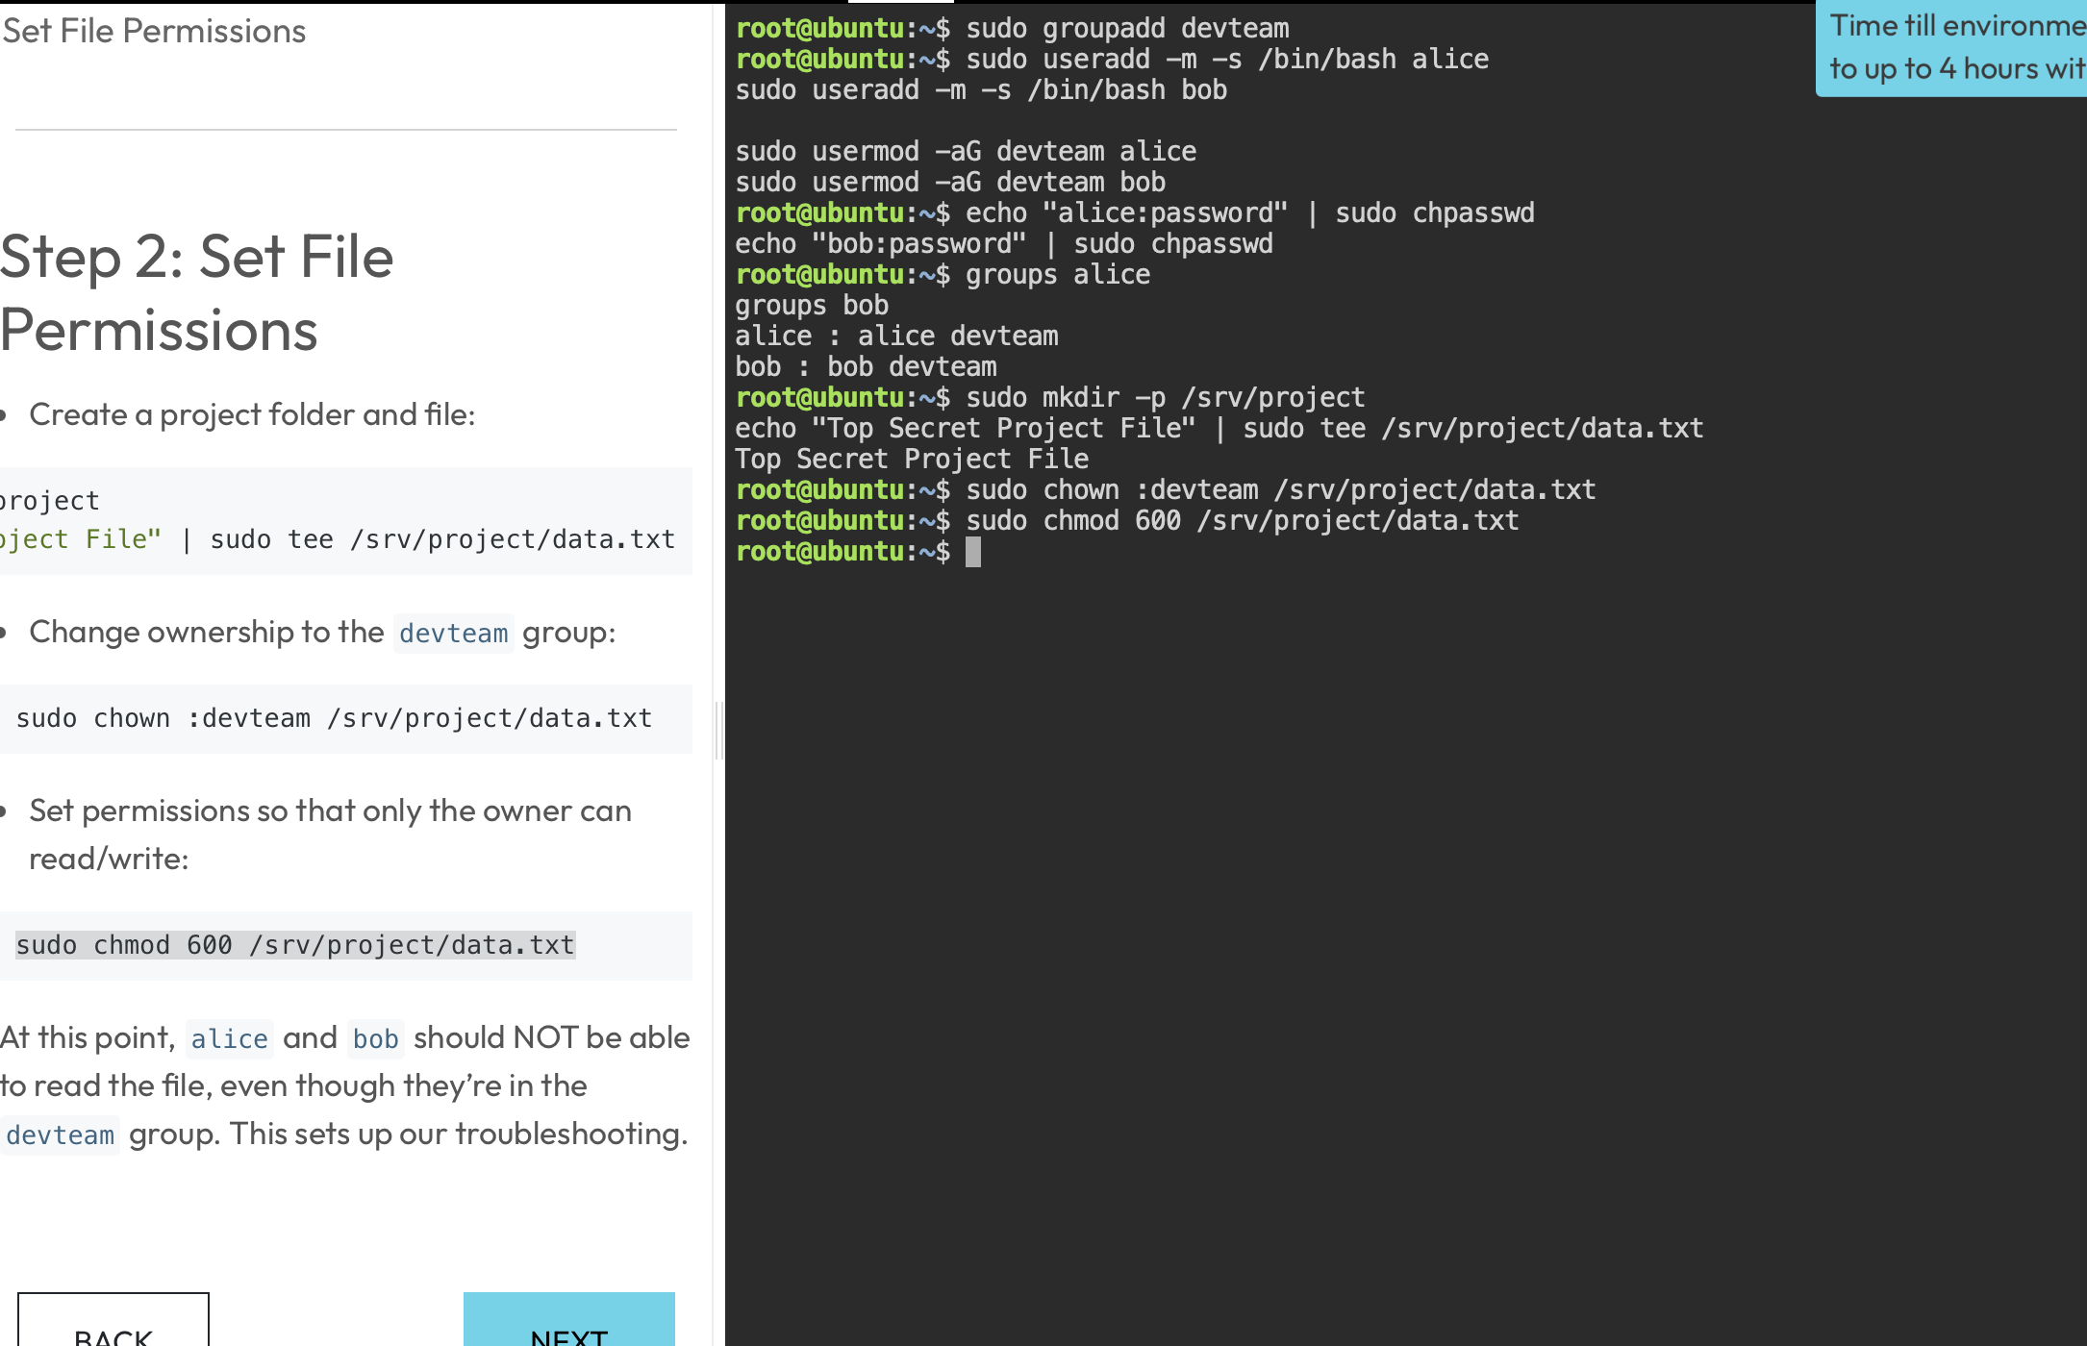
Figure: Screenshot 2026-06-13 at 6.17.38 PM.png

Linux Network Service Troubleshooting
Verified service processes, ports, connectivity, and application availability.
